Teacher Guidance:
Using this resource:
This resource aims to improve calculator fluency by highlighting misconceptions about calculator entry. This resource can be used for all secondary pupils, however, it may be most appropriate for KS3 classes.
The resource can be projected on the board, or printable versions are available.
Printable documents have been resized so that two worksheets (1 per student) are printed on each page.
Calculator Guidance:
Question L requires students to use the % button in the catalogue.
- Find this by pressing CATALOG T > Probability 2 > % 1
Going Deeper:
These questions extend students’ calculator skills by probing them to think about how the use of the answer button, brackets or other changes to the input may affect the correct answer. Students should draw on ideas about negative numbers and BIDMAS, and how inputs are interpreted by calculators.
Going deeper questions are available on the PowerPoint version of this resource.

Use your calculator to find the odd-one-out in each row. Give a reason for your answer.

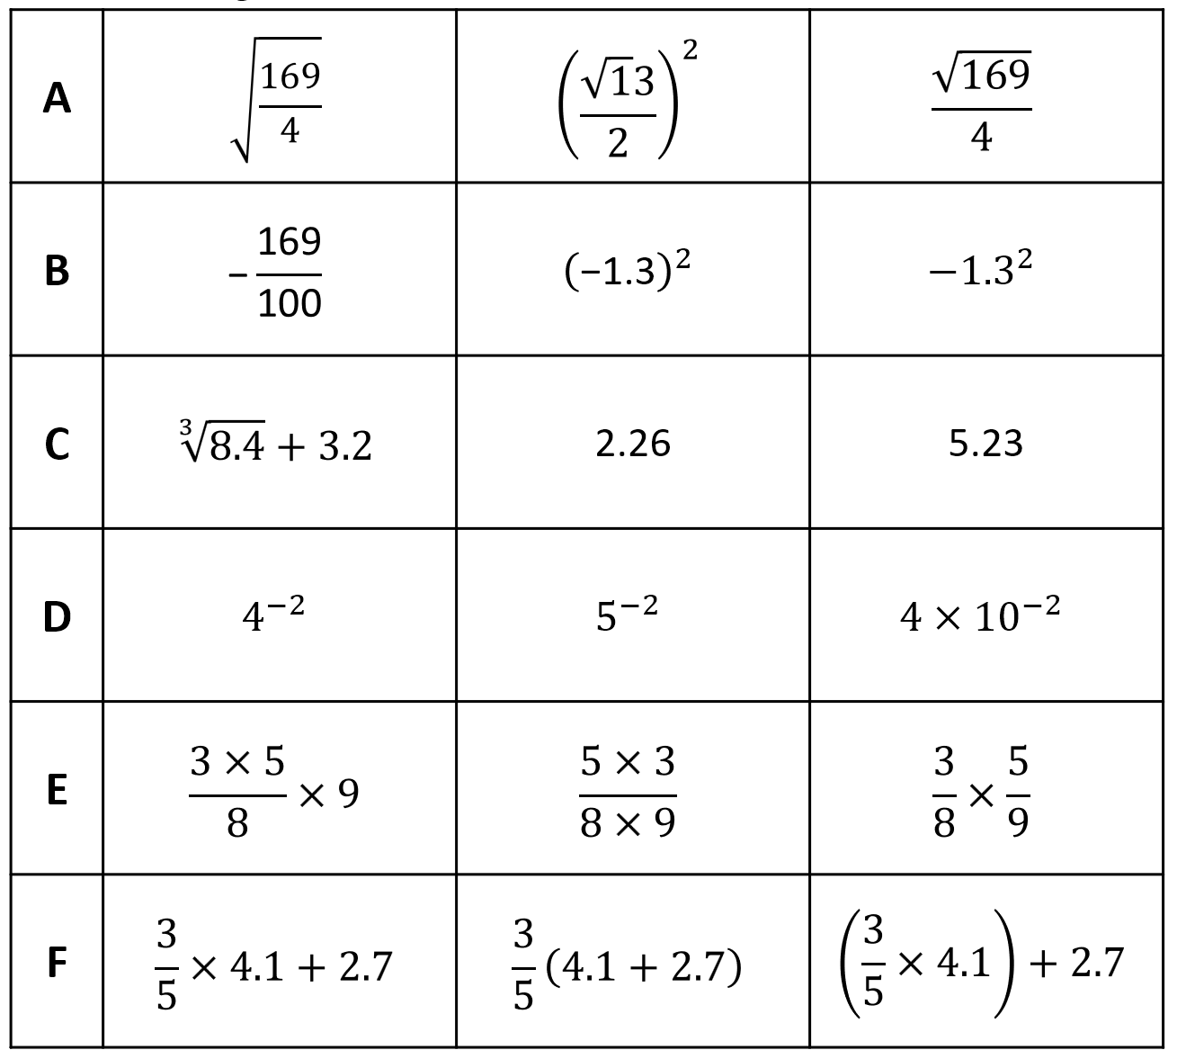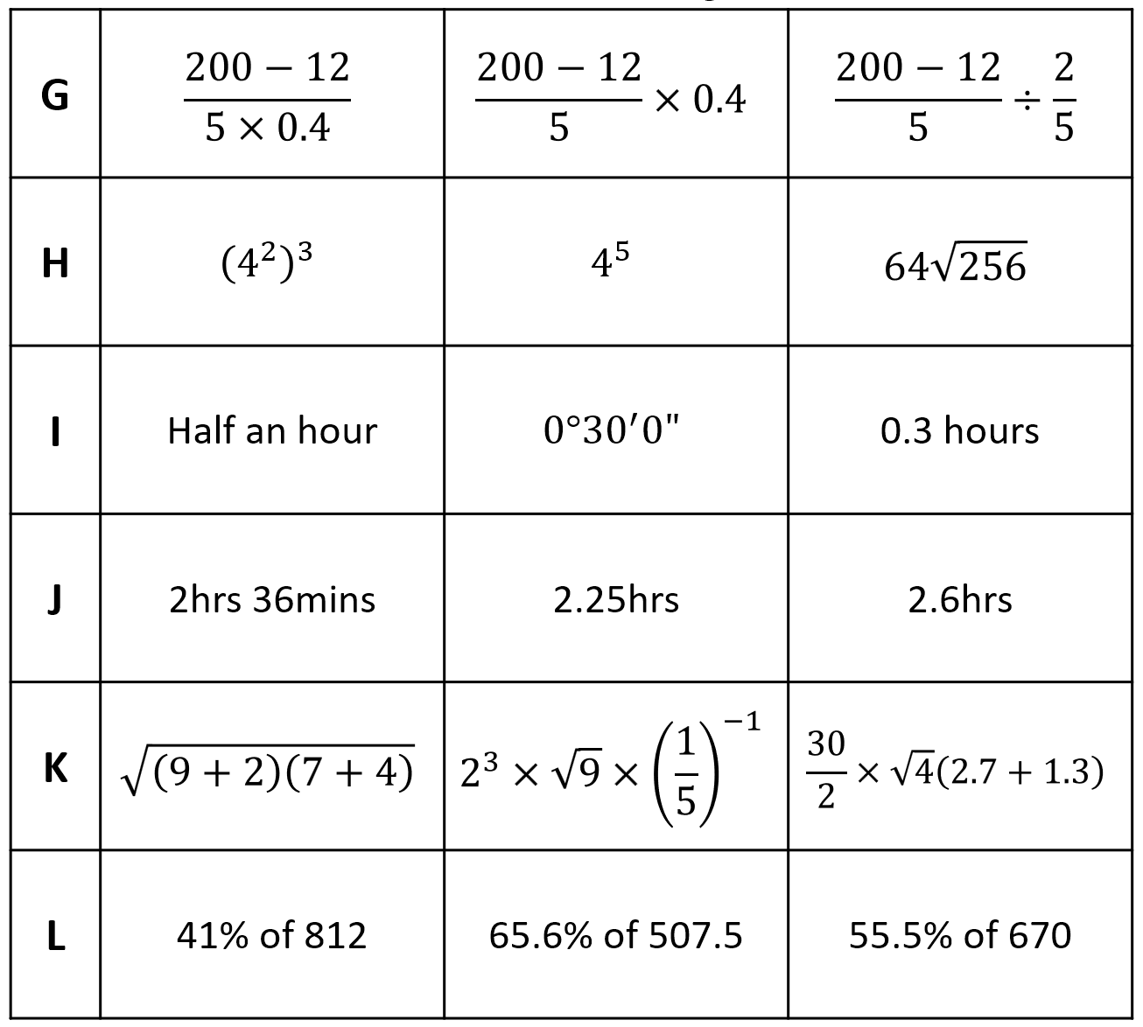


Calculator Skills: Odd-One-Out
fx-83GT CW+, fx-85GT CW+, fx-991 CW+ UK
Use your calculator to find the odd-one-out in each row. Give a reason for your answer.

